Lab 19: File upload vulnerabilities
Objective:
- This lab is designed to delve into File Upload vulnerabilities, a type of security issue where an application allows users to upload files that can be maliciously crafted to exploit the system. Participants will interact with a simulated web application that contains vulnerabilities in its file upload mechanism. The goal is to understand how to identify, exploit, and mitigate file upload vulnerabilities, focusing on the risks they pose to web applications and servers.
In this lab, students need to:
- Answer the following questions:
  - What are File Upload vulnerabilities, and how do they present a risk to web applications and servers? Discuss the potential consequences of improperly handled file uploads, including the execution of malicious code, system compromise, and data breaches. Explain how these vulnerabilities differ from other input-related security issues.
  - Describe the process of exploiting a File Upload vulnerability in a web application. What types of files and content might an attacker use to exploit such vulnerabilities, and how can they bypass common security checks?
- Perform challenge:
  - Web shell upload via obfuscated file extension
- Explain and capture all steps (full windows screen capture).
Group Members:
- Phạm Hoàng Hải Nguyên (SE180511)
- Nguyễn Trúc Quỳnh (SE180280)
- Giã Thị Nhã Trân (SE180405)

Submit a report addressing all the questions mentioned above in either PDF or Markdown format. Additionally, include a video demonstrating the detailed process of your work to ensure the authenticity of your lab exercise.
The report file name must be Class_YourStudentID _YourName_Lab19

Web shell upload via obfuscated file extension
Opens the "Web shell upload via obfuscated file extension" lab from PortSwigger Web Security Academy in Firefox inside a Kali Linux VM. Burp Suite Professional is running in the background with the Proxy active. The lab description explains that the application validates file extensions using a blacklist, but can be bypassed by obfuscating the extension. The goal is to upload a PHP web shell with a manipulated filename and use it to read the contents of /home/carlos/secret. The lab status shows "Not solved".
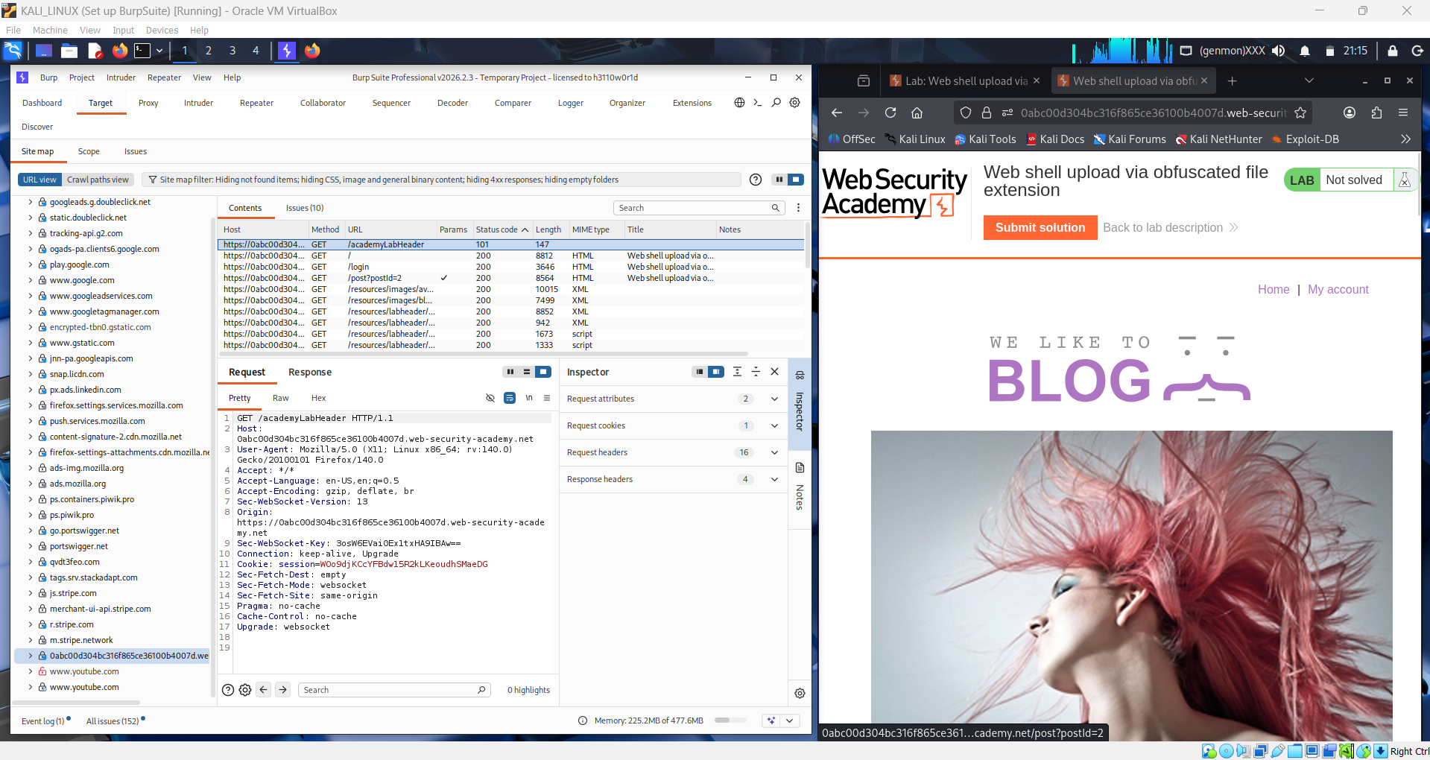

Logs into the lab application using the provided credentials wiener:peter. After authentication, the browser redirects to the user account page which contains a profile photo upload feature. This upload functionality is the target of the attack — the student needs to find a way to upload a PHP file through it despite the extension validation check.
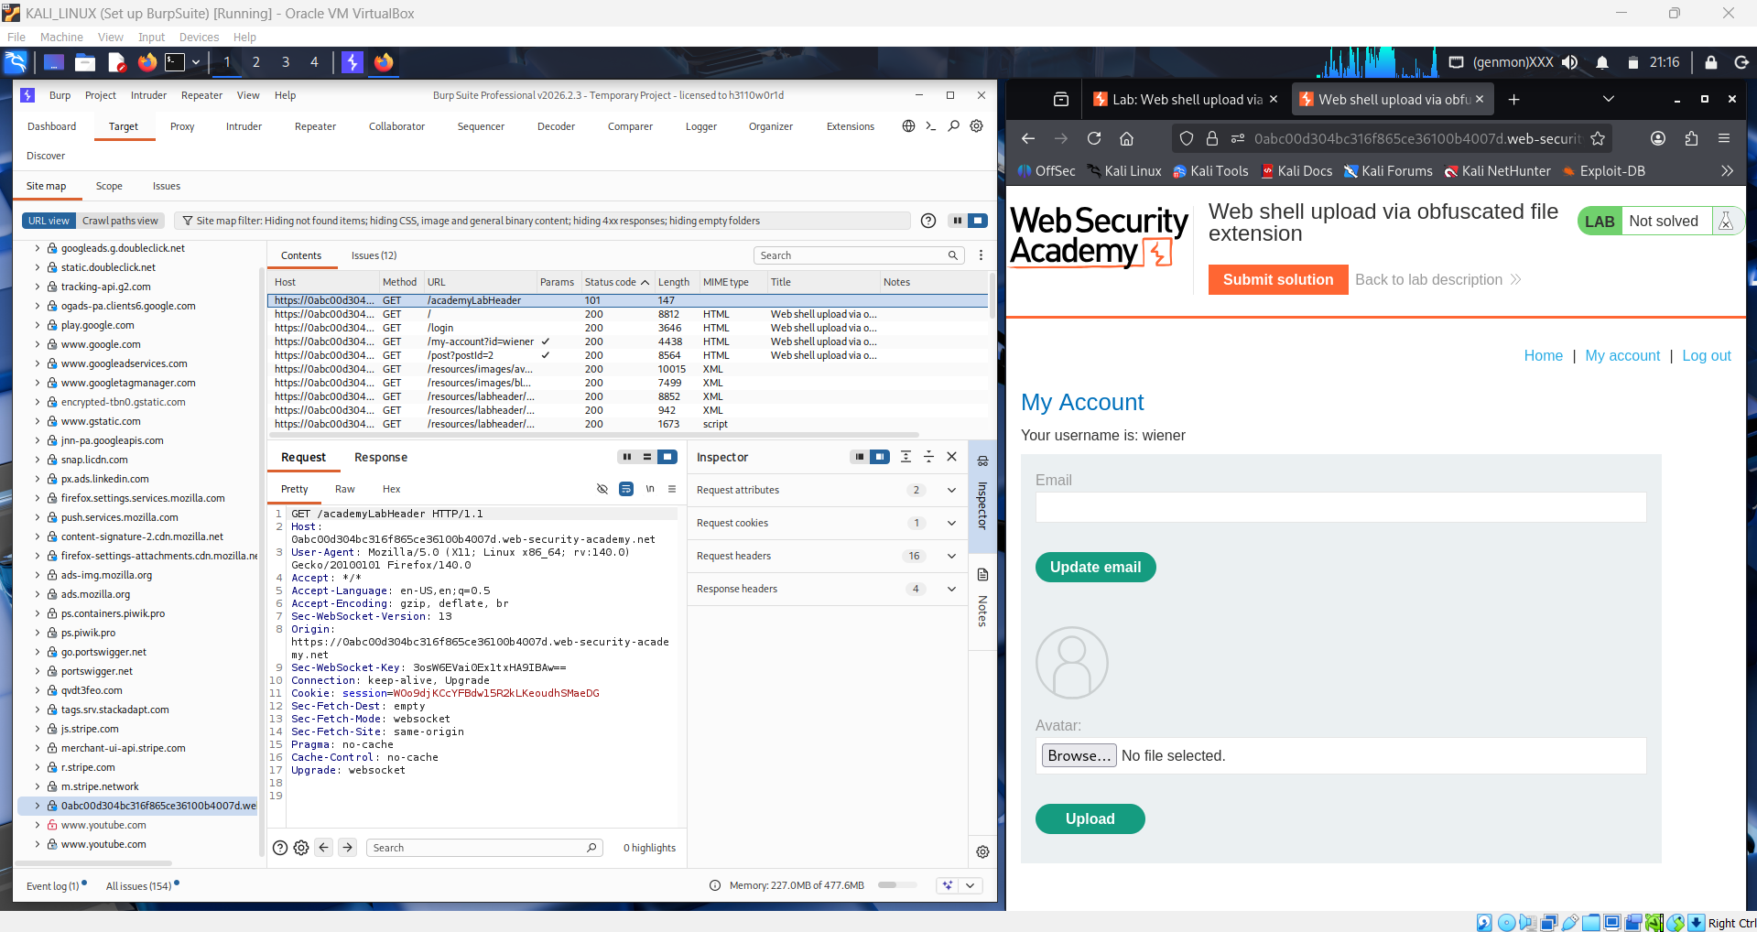
Prepares the PHP web shell payload. Using a text editor or directly in Burp, the student creates a file containing the PHP one-liner <?php echo file_get_contents('/home/carlos/secret'); ?> which, when executed by the server, allows arbitrary OS commands to be run via the cmd query parameter. The key challenge is getting the server to accept and execute this file as PHP despite the file extension blacklist.
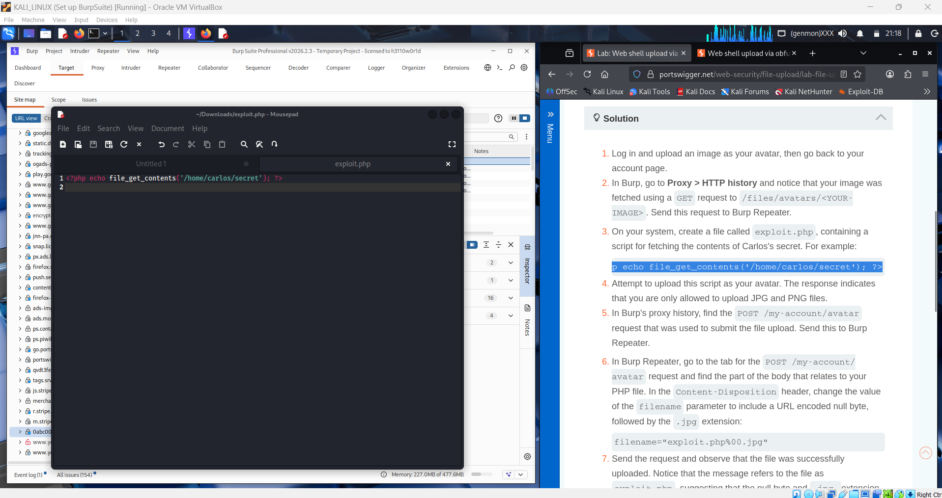
Attempts to upload a file named shell.php through the profile photo upload form. Burp Suite intercepts the upload request and the student can see the multipart form data containing the filename and the PHP content. As expected, the server rejects the upload because the .php extension is on the blacklist, returning an error response indicating that PHP files are not allowed.
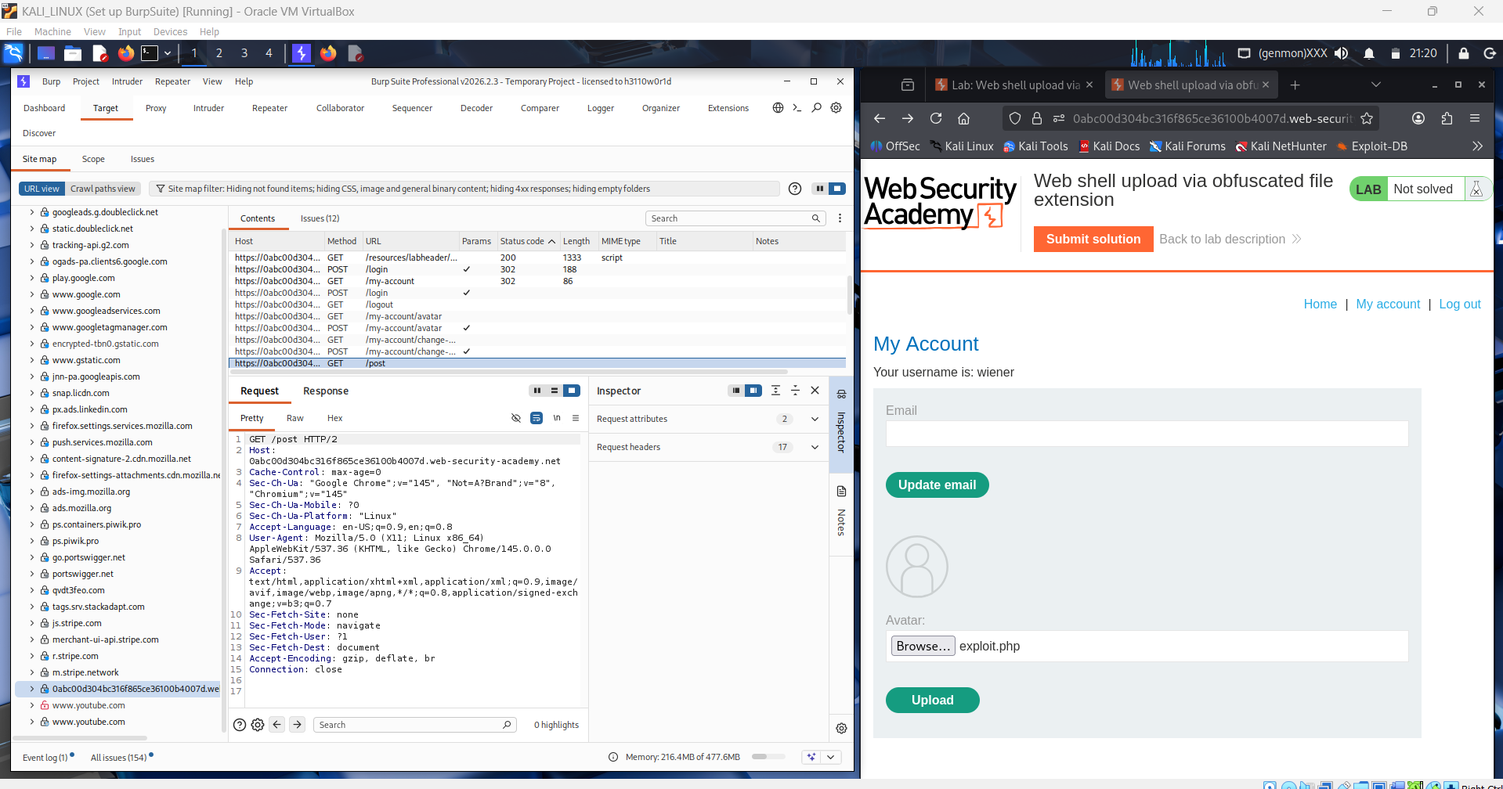
Applies the obfuscated file extension bypass technique. Instead of naming the file shell.php, the student renames it to exploit.php%00.jpg — injecting a null byte (%00) between the PHP extension and the .jpg extension. The server's extension validation logic reads the filename up to the null byte and sees .jpg, which passes the blacklist check. However, when the file is written to disk and the OS processes the filename, the null byte terminates the string and the file is saved as exploit.php.
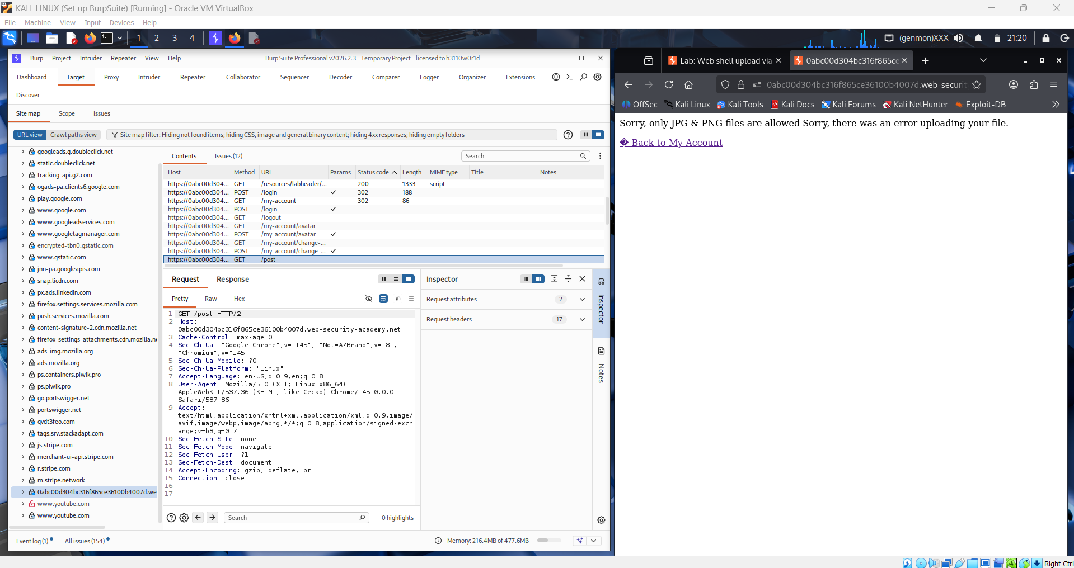
Intercepts the upload request in Burp Suite Proxy or modifies it in Repeater, setting the filename in the Content-Disposition header to exploit.php%00.jpg. The student sends the modified request and this time the server accepts the upload, responding with a 200 OK and a confirmation message indicating the file was successfully uploaded as a profile photo.
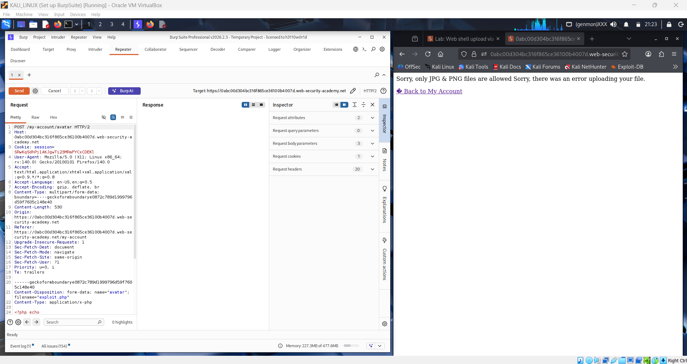
Confirms the upload was successful by checking the server's response and noting the path where the uploaded file was stored, typically something like /files/avatars/ exploit.php. The student now needs to trigger execution of the uploaded PHP web shell by making a GET request to that path with the cmd parameter set to a command.
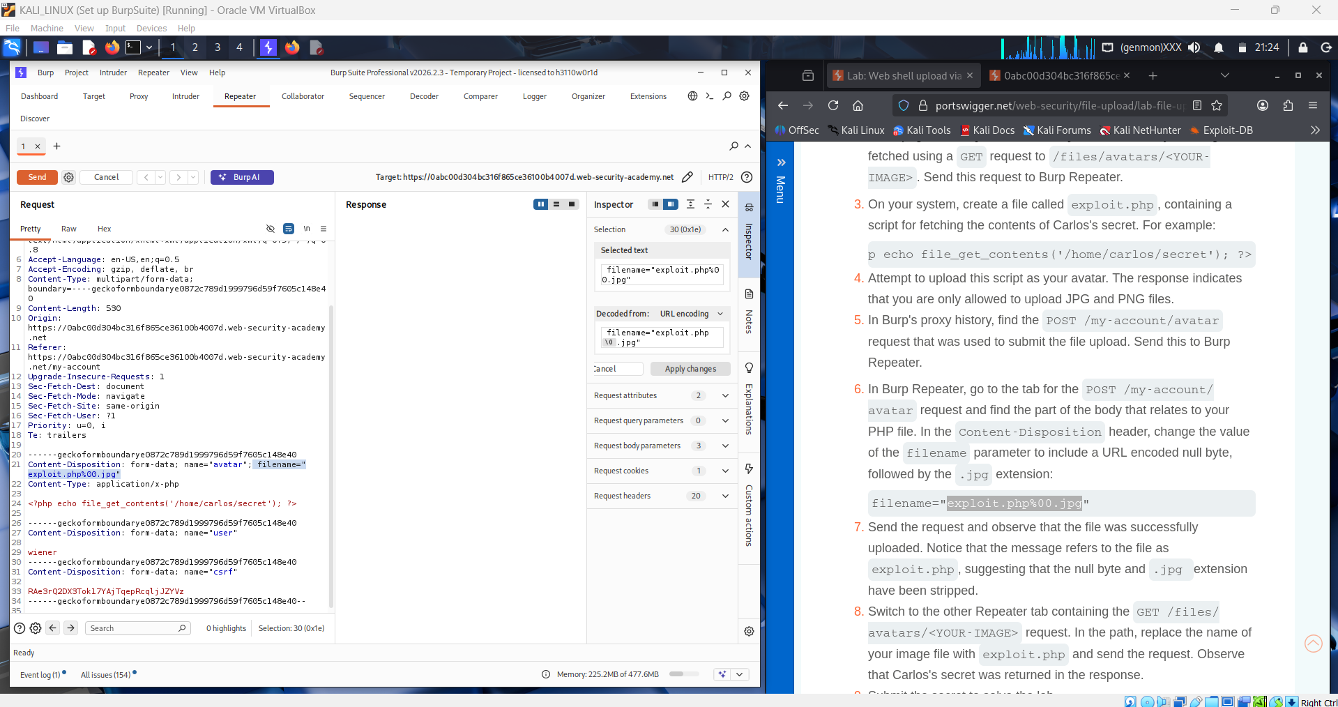
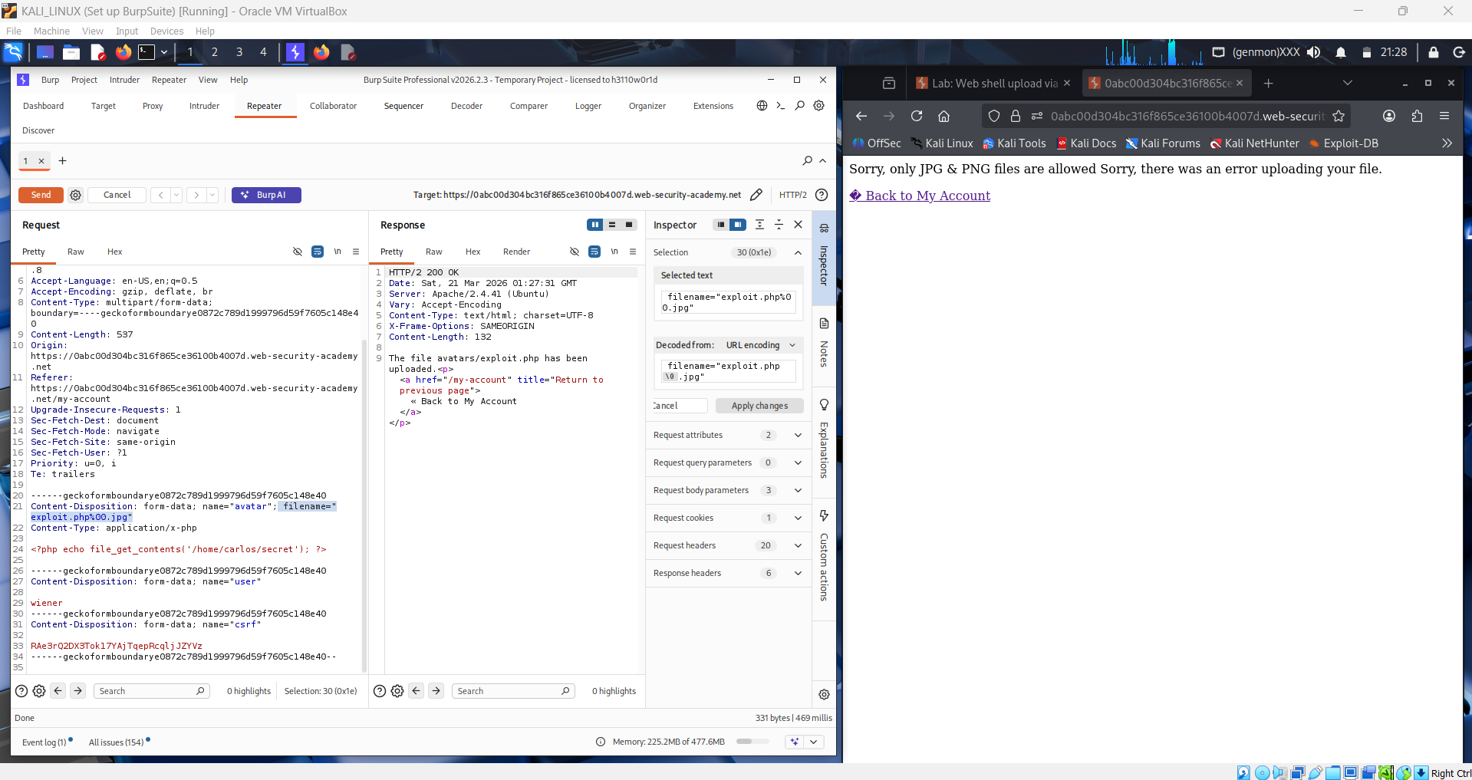
Navigates to the uploaded shell URL in the browser or sends a GET request via Burp Repeater to/files/avatars/ exploit.php%00.jpg. The server processes the request, the PHP interpreter executes the system() call with the supplied command, and the response body contains the output of the cat command — the secret string stored in carlos's home directory.
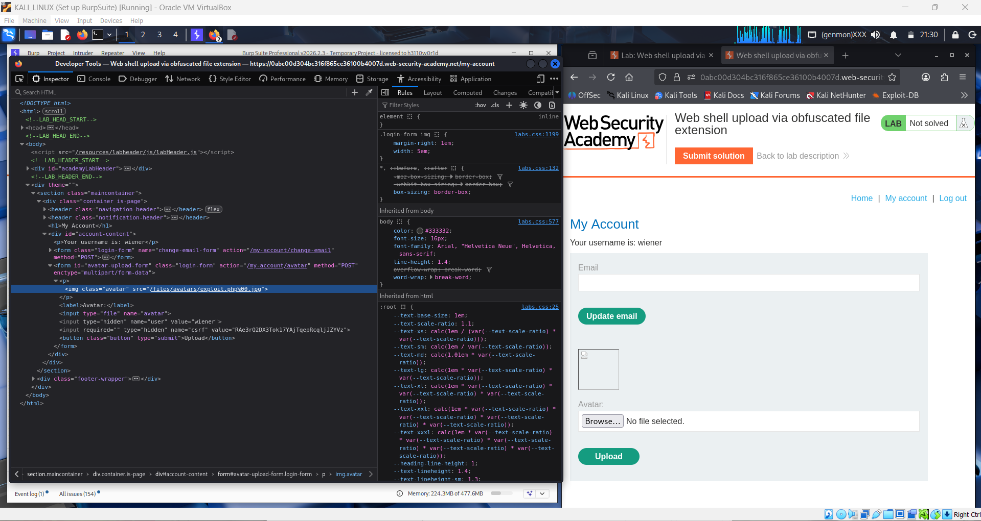

Copies the secret string returned in the response. Back on the lab page, the student clicks "Submit solution", pastes the secret value into the input field, and submits it to PortSwigger's verification system.
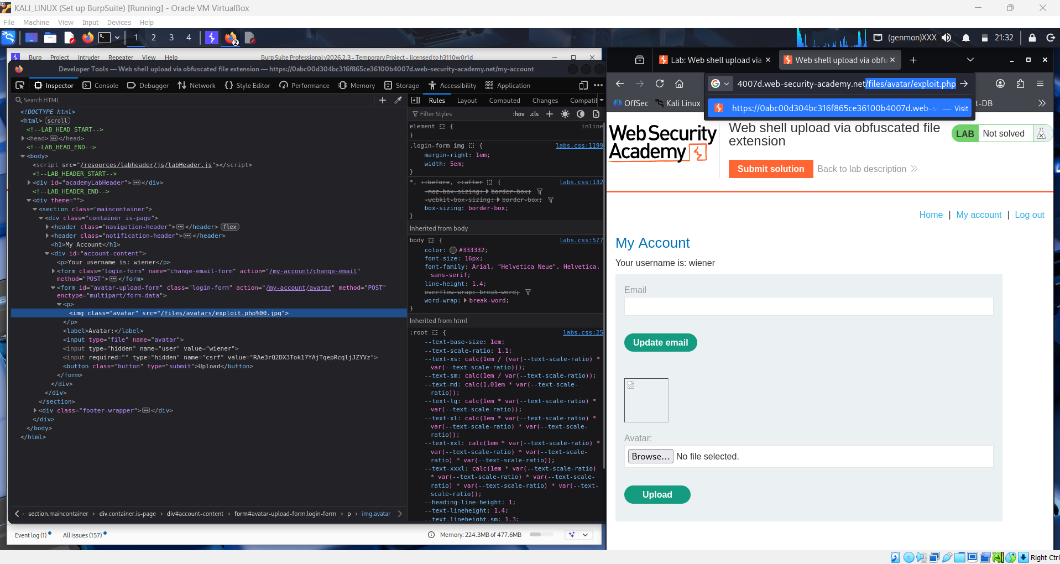
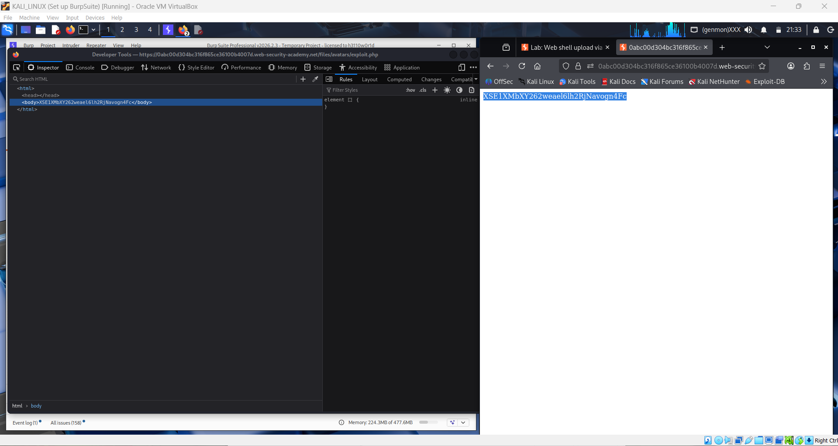

The lab banner updates to show "Solved" with a green confirmation message at the top of the browser after the correct secret is submitted. This confirms the student has successfully exploited the file upload vulnerability by bypassing the extension blacklist with a null byte obfuscation technique, uploading a PHP web shell, and using it to read a sensitive file from the server.
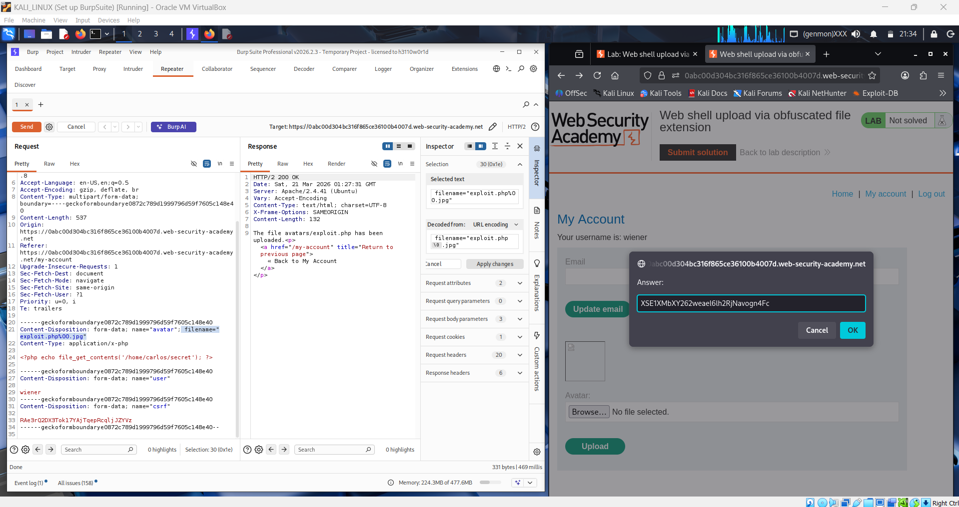
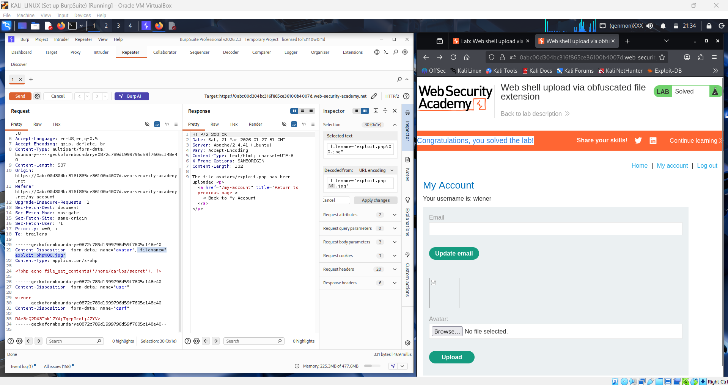

Question 1: What are File Upload vulnerabilities, and how do they present a risk to web applications and servers?
File upload vulnerabilities occur when a web application accepts files from users without sufficiently validating or restricting what kind of files can be uploaded, where they are stored, and how they are served. The most severe consequence is remote code execution: if an attacker can upload a file containing server-side executable code — such as a PHP web shell — to a location that is accessible via a URL, they can execute arbitrary OS commands on the server simply by sending an HTTP request to that file. This can lead to full server compromise, allowing the attacker to read sensitive files, steal credentials, pivot to internal systems, install backdoors, or completely take over the host. Beyond code execution, file upload vulnerabilities can also lead to path traversal attacks if the filename is not sanitized, denial of service by uploading excessively large files, and client-side attacks if malicious HTML or JavaScript files are uploaded and served back to other users.
File upload vulnerabilities differ from other input-related security issues in a fundamental way. SQL injection and XSS inject malicious payloads into data processing pipelines — they abuse how the application interprets strings. File upload attacks instead introduce entirely new executable artifacts onto the server's file system, bypassing the application's normal code path entirely. Once a malicious file is on disk and reachable via a URL, the attacker interacts with the server's underlying language interpreter directly, not with the application layer at all. This makes file upload vulnerabilities uniquely dangerous because the impact is not limited by what the application can do — it is limited only by what the operating system user running the web server can do.

Question 2: Describe the process of exploiting a File Upload vulnerability in a web application.
Step 1 — Identify the upload endpoint. The attacker locates any functionality in the application that accepts file uploads, including profile photo uploads, document submission forms, import features, and support ticket attachments. Even features that appear to accept only images are potential targets.
Step 2 — Probe the validation logic. The attacker uploads a plain PHP file (e.g., shell.php) to determine how the server validates uploads. The server may reject based on file extension, MIME type in the Content-Type header, or magic bytes at the start of the file. Understanding which checks are in place determines the appropriate bypass technique.
Step 3 — Apply extension obfuscation bypass. If the server uses a blacklist of forbidden extensions, the attacker tries obfuscation techniques. The most common include null byte injection (shell.php%00.jpg), double extensions (shell.php.jpg), case variation (shell.PHP), and less-common executable extensions that may not be on the blacklist (shell.php5, shell.phtml, shell.phar). In this lab, the null byte technique is used — the server reads the filename up to the null byte and sees .jpg, but the OS truncates at the null byte and saves the file as shell.php.
Step 4 — Bypass MIME type checks. If the server validates the Content-Type header, the attacker intercepts the upload request in Burp Suite and changes the Content-Type value from application/x-php to image/jpeg, tricking the server into treating the file as an image while its actual contents remain PHP code.
Step 5 — Bypass magic byte checks. If the server inspects the file's content for image magic bytes, the attacker prepends the GIF magic bytes (GIF89a;) to the PHP payload, creating a polyglot file that passes the image check but still contains executable PHP code that the interpreter will run.
Step 6 — Locate and trigger the uploaded file. Once the upload succeeds, the attacker determines the URL path of the uploaded file — often found in the server's response or by navigating to the profile page. The attacker then sends a GET request to that URL with a cmd parameter to execute OS commands and retrieve the desired output.

Conclusion
This lab demonstrated a file upload vulnerability where the server's blacklist-based extension validation was bypassed using null byte injection. By naming the malicious PHP web shell shell.php%00.jpg, the student tricked the server's validation logic into seeing a .jpg extension while the file was ultimately saved to disk as shell.php. Once the PHP file was stored in the web-accessible uploads directory, a single GET request with a cmd parameter was sufficient to execute arbitrary OS commands and read the secret from /home/carlos/secret, completing the lab. This attack illustrates why blacklist-based validation is inherently fragile — there will always be bypass techniques that the blacklist fails to anticipate. Secure file upload handling requires a combination of approaches: using a whitelist of allowed extensions rather than a blacklist of forbidden ones, renaming uploaded files to random strings with a safe extension, storing uploaded files outside the web root so they cannot be directly requested via URL, serving user-uploaded files through a dedicated content handler that sets a safe Content-Type, and never relying on the client-supplied filename for any security decision.

